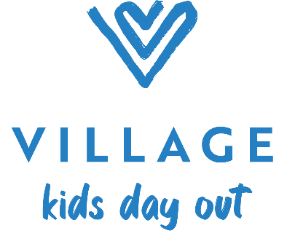
Kid’s Day Out Monthly Tuition
2025-2026

Tuesday/Thursday KDO 9:30-2:30 2 years – 3 years (as of 9/1/2023) $350

Enrollment Fees:
Enrollment Fee (non-refundable) $100
Tuition Deposit $350

(This deposit will be applied to your account as September 2025 tuition and will hold your spot for the upcoming year.)

Enrollment will be confirmed within two (2) business days with instructions on paying Registration fee and Tuition deposit.

Make checks payable to: Village KDO

